Magics RP for Nexa3D

# Installation Instructions & Support Guidelines

Contents

Installation Instructions & Support Guidelines 1

1. Installation 3

How to install 3

2. Licensing 5

Working with a Local License 5

Activating Your License 5

3. Sending a Support Request 7

4. Additional Support 8

Manual 8

Additional Contacts 8

# Installation

Nexa3D will supply you with an installer for the Materialise RP along with an installer for the Nexa3D Build Processor. You can log on to passwords.materialise.com with your CCKey to access the installer for the latest version of Magics RP. If you already have MagicsPrint for Nexa3D installed, you only need to run the installer for Magics RP.

The installer link for the MagicsPrint for Nexa3D can also be found here:

<https://www.dropbox.com/s/u9110uqeriia9f4/Magics_Print_for_Nexa3D_23.2.16.113_x64.exe?dl=0>

The Build Processor if part of a ‘bundled installer,’ with several components included. When using Magics RP with the Nexa3D Build Processor, you do not need to install MagicsPrint for Nexa3D. You can uncheck the box for ‘Complete’ and check the box for ‘Build Processor Only’ when installing using the instructions outlined below.

The ‘Build Processor Only’ installer will install the following components:

• Microsoft® .NET Framework 4.5

• Materialise Local License Server 7.0

• Build Processor System 2.0

• Nexa3D Build Processor

Please note

We recommend that you close all other applications before installing the software.

Administrative rights are required to install the software.

## How to install

First install Magics:

1. Double click the product installer for Magics RP.
2. Select the language you want to use and click OK to proceed.
3. Select the folder where you want to install Magics RP and the Nexa3D Build Processor. You can specify a new directory via the browse button.

After reading the license agreements:

* + - Materialise EULA
    - Microsoft DirectX EULA

Select the “I agree with…” checkbox and click on the ***Install*** button.

If prompted to reboot your system after installation, please do so.

1. The software is now successfully installed. Click ***Associate Files*** to select the file types you wish to open with the Magics RP software.

Select the file types you want to open with the Magics RP software. It is advised to keep the standard settings. You can always change the associated files whenever needed via the Settings > File I/O > File associations menu

Now install the Nexa3D Build Processor:

1. Double click the installer for MagicsPrint for Nexa3D.
2. Select the ‘Build Processor only’ option and install.

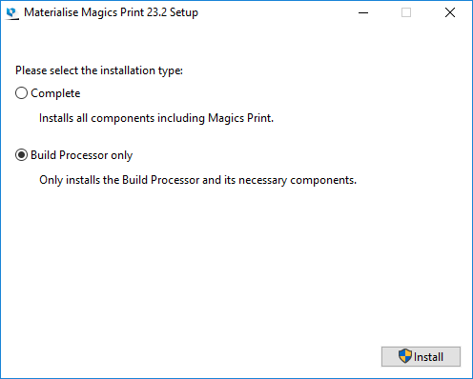

1. Select the language you want to use and click OK to proceed.
2. Select the folder where you want to install Magics RP and the Nexa3D Build Processor. You can specify a new directory via the browse button.

After reading the license agreements:

* + - Materialise EULA
    - Microsoft DirectX EULA

Select the “I agree with…” checkbox and click on the ***Install*** button.

If prompted to reboot your system after installation, please do so.

The software is now successfully installed.

# Licensing

Once the Materialise Magics RP software and the Nexa3D Build Processor have been successfully installed, you will need to activate your license. Nexa3D will supply you with a CCKey for your license. Your license should contain Magics RP with the SG (support generation) module and the Nexa3D Build Processor. This CCKey needs to be tied to the System ID of your computer in order for you to use the software. The System ID is specific to Materialise software and unique to each computer. You have to have Materialise software installed before you can view your System ID.

## Working with a Local License

Local Licensing is the traditional system with the license stored locally on each computer (see figure below). The software can only be used on the computer for which the license is issued. However, more than one session of Materialise Magics RP & Build Processor can be opened on a single computer. If you need to move the software to a different computer, please contact your Nexa3D support representative.

**Local PC(s)**

## Activating Your License

There are multiple ways to activate your MagicsPrint for Nexa3D license.

Instant activation

The easiest way to activate your software is through instant activation. To use instant activation, your computer needs to be connected to the internet. With instant activation, you can input your CCKey and Magics RP will retrieve a keyfile to unlock the software automatically.

Please open Magics RP and the registration wizard will appear. Select ‘License’ and hit ‘Next’. Choose the option for ‘Instant activation (recommended)’ and hit ‘Next.’ Copy/paste your 16 digit code into the boxes, and click ‘Next’. Your voucher should now be registered.

Some firewalls or network security may block instant activation. If this is the case, please manually upload a keyfile using the instructions below.

Passwords website

If instant activation does not work for you or your computer is offline, you can activate your license by manually retrieving a keyfile.

Please open Magics RP and the registration wizard will appear. Select ‘Show license and system information’ and hit ‘Next’. Copy your System ID to your clipboard. Go to <https://passwords.materialise.com/> and enter your 16 digit CCKey to log in. Paste your System ID from your clipboard into the System ID box. Enter your email if is it not already populated. Click ‘Next’ to email yourself a keyfile.

Once you receive the keyfile via email, save it locally. Go back to the registration wizard. Starting from the main page, click ‘License’ then ‘Next.’ Then click ‘I want to register a license key file I received via email’ and click ‘Next.’ Now browse for the keyfile and click ‘Next.’ Your license should now be active.

You can delete the keyfile from your computer once it has been loaded into the registration wizard.

For an offline computer, simply retrieve the keyfile using the steps above to email yourself a keyfile. Be sure to use the System ID for the offline computer. Save the keyfile to a USB or use some other file transfer method to get the keyfile to the offline computer. Load the keyfile using the steps described above.

Additional options

The registration wizard also includes an option to apply for a keyfile via email. If you Nexa3D representative sends you a keyfile for your license, you can register it using the ‘I want to register a license key file I received via email’ option in the registration wizard.

For additional instructions on how to (re)activate your Materialise software licenses, please consult:

[http://software.materialise.com/frequently-asked-questions-materialise-software](http://software.materialise.com/frequently-asked-questions-materialise-software%20)

# Sending a Support Request

Magics RP allows you to send a support request by email to the customer support team of your Materialise office (Options&Help\Support). This can be done by filling out the request form and by selecting the type of additional information you want to add to the request.

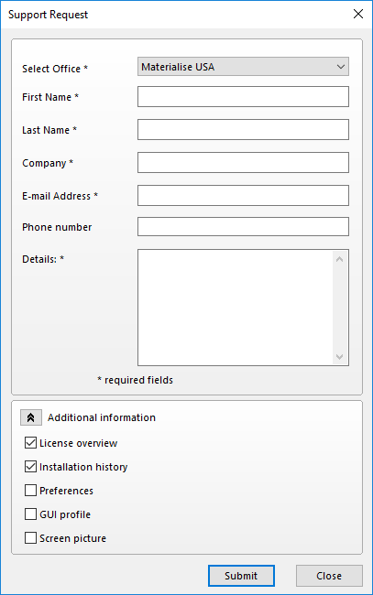

To make sure that our customer support team has enough information regarding the problem, additional information can be included. You can select to add this information to your support request, which will give the customer support team more information about your Magics RP configuration. By sharing this information it is more likely that your support case will be solved more swiftly.

# Additional Support

## Manual

You can access the manual for Magics RP from within the software by going to Options&Help\Manual.

## Additional Contacts

For additional support, please contact your Nexa3D account representative.

You can contact Materialise directly by sending an email to [software.support@materialise.com](mailto:software.support@materialise.com) or call the support line at (734) 259-6445. Please include the software version of Magics RP and your CCKey when sending in a support request.