Switching from

MagicsPrint DLP to

MagicsPrint for Nexa3D

# Installation Instructions & Support Guidelines

Contents

Installation Instructions & Support Guidelines 1

1. Uninstalling MagicsPrint DLP 3

2. Installing MagicsPrint for Nexa3D 4

How to install 4

3. Licensing 5

Working with a Local License 5

Activating Your License 5

4. Managing your Machines 7

5. Sending a Support Request 8

6. Additional Support 9

Manual 9

Additional Contacts 9

This instruction guide explains how to switch from MagicsPrint DLP to MagicsPrint for Nexa3D. To make the switch, you will need to first uninstall MagicsPrint DLP then install MagicsPrint for Nexa3D.

# Uninstalling MagicsPrint DLP

Go to your Windows ‘Uninstall or change a program’ page. Uninstall the Build Processor System, Materialise Magics Print 23.2, and the Standard DLP Build Processor Beta 1.1. Once you uninstall all three programs, restart your computer.

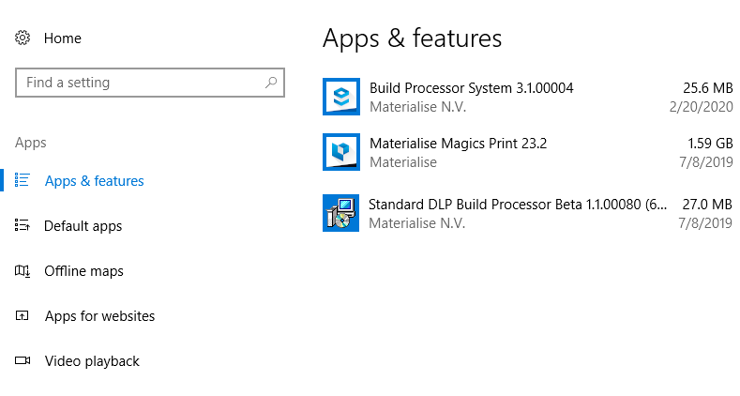

You can uninstall MagicsPrint and the Build Processor at the same time by running a ‘Complete’ uninstall when uninstalling MagicsPrint.

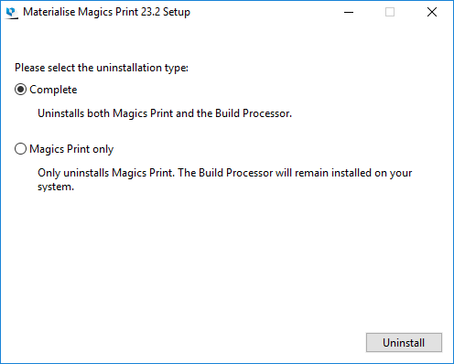

# Installing MagicsPrint for Nexa3D

Now you are ready to install MagicsPrint for Nexa3D. Nexa3D will supply you with an installer for the Materialise MagicsPrint for Nexa3D Software.

The installer link can also be found here: <https://www.dropbox.com/s/u9110uqeriia9f4/Magics_Print_for_Nexa3D_23.2.16.113_x64.exe?dl=0>

This is a ‘bundled installer,’ meaning that it will install all the necessary components to run the product. These include:

• Microsoft® .NET Framework 4.5

• Materialise Local License Server 7.0

• Build Processor System 2.0

• Nexa3D Build Processor

• MagicsPrint for Nexa3D Software

Please note

We recommend that you close all other applications before installing MagicsPrint for Nexa3D.

Administrative rights are required to install the software.

## How to install

1. Double click the product installer.
2. Select the language you want to use and click OK to proceed.
3. Select the folder where you want to install MagicsPrint for Nexa3D. You can specify a new directory via the browse button.

After reading the license agreements:

* + - Materialise EULA
    - Microsoft DirectX EULA

Select the “I agree with…” checkbox and click on the ***Install*** button.

If prompted to reboot your system after installation, please do so.

1. The software is now successfully installed. Click ***Associate Files*** to select the file types you wish to open with the MagicsPrint for Nexa3D software.

Select the file types you want to open with the MagicsPrint for Nexa3D software. It is advised to keep the standard settings. You can always change the associated files whenever needed via the Settings > File I/O > File associations menu

# Licensing

Once the Materialise MagicsPrint for Nexa3D software and the Build Processor have been successfully installed, you will need to activate your license. Nexa3D will supply you with a CCKey for your license. This CCKey needs to be tied to the System ID of your computer in order for you to use the software. The System ID is specific to Materialise software and unique to each computer. You have to have Materialise software installed before you can view your System ID.

## Working with a Local License

Local Licensing is the traditional system with the license stored locally on each computer (see figure below). The software can only be used on the computer for which the license is issued. However, more than one session of Materialise MagicsPrint for Nexa3D software & Build Processor can be opened on a single computer. If you need to move the software to a different computer, please contact your Nexa3D support representative.

**Local PC(s)**

## Activating Your License

There are multiple ways to activate your MagicsPrint for Nexa3D license.

Instant activation

The easiest way to activate your software is through instant activation. To use instant activation, your computer needs to be connected to the internet. With instant activation, you can input your CCKey and MagicsPrint for Nexa3D will retrieve a keyfile to unlock the software automatically.

Please open MagicsPrint for Nexa3D and the registration wizard will appear. Select ‘License’ and hit ‘Next’. Choose the option for ‘Instant activation (recommended)’ and hit ‘Next.’ Copy/paste your 16 digit code into the boxes, and click ‘Next’. Your voucher should now be registered.

Some firewalls or network security may block instant activation. If this is the case, please manually upload a keyfile using the instructions below.

Passwords website

If instant activation does not work for you or your computer is offline, you can activate your license by manually retrieving a keyfile.

Please open MagicsPrint for Nexa3D and the registration wizard will appear. Select ‘Show license and system information’ and hit ‘Next’. Copy your System ID to your clipboard. Go to <https://passwords.materialise.com/> and enter your 16 digit CCKey to log in. Paste your System ID from your clipboard into the System ID box. Enter your email if is it not already populated. Click ‘Next’ to email yourself a keyfile.

Once you receive the keyfile via email, save it locally. Go back to the registration wizard. Starting from the main page, click ‘License’ then ‘Next.’ Then click ‘I want to register a license key file I received via email’ and click ‘Next.’ Now browse for the keyfile and click ‘Next.’ Your license should now be active.

You can delete the keyfile from your computer once it has been loaded into the registration wizard.

For an offline computer, simply retrieve the keyfile using the steps above to email yourself a keyfile. Be sure to use the System ID for the offline computer. Save the keyfile to a USB or use some other file transfer method to get the keyfile to the offline computer. Load the keyfile using the steps described above.

Additional options

The registration wizard also includes an option to apply for a keyfile via email. If you Nexa3D representative sends you a keyfile for your license, you can register it using the ‘I want to register a license key file I received via email’ option in the registration wizard.

For additional instructions on how to (re)activate your Materialise software licenses, please consult:

[http://software.materialise.com/frequently-asked-questions-materialise-software](http://software.materialise.com/frequently-asked-questions-materialise-software%20)

# Managing your Machines

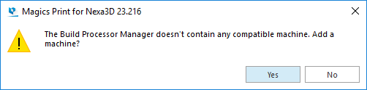When you first launch MagicsPrint for Nexa3D you will get the message below:

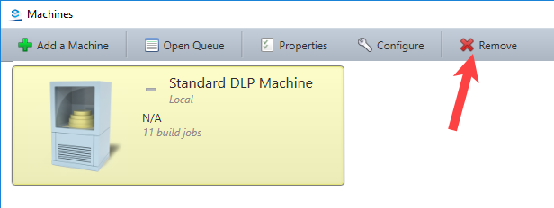Press ‘Yes’ to launch the Build Processor Manager. If you see the Standard DLP Machine, you should select the machine and press ‘Remove.’

Now select ‘Add a Machine’ in the top right corner. Select the Nexa3D NXE400 machine and press ‘Add’ in the bottom right corner. On the next page press ‘Add’ then press ‘Yes’ on the pop-up. Once the machine is installed you can close out of the install page, configure machine page, and the build processor manager.

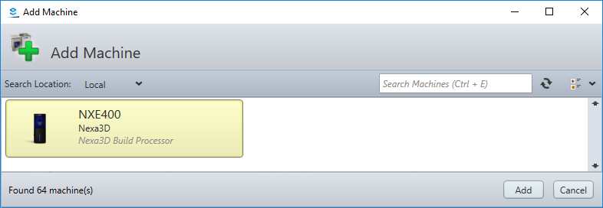

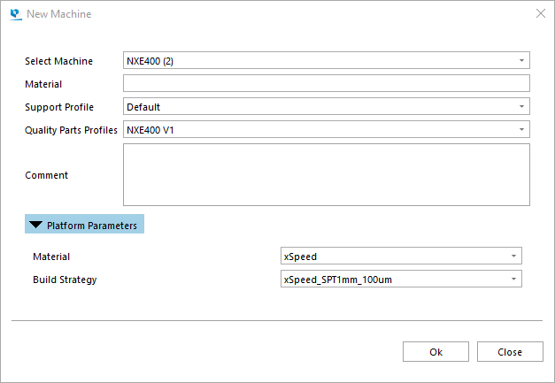Now when you launch MagicsPrint for Nexa3D you should see the image shown to the right. Press ‘OK’ and you are ready to use the software.

# Sending a Support Request

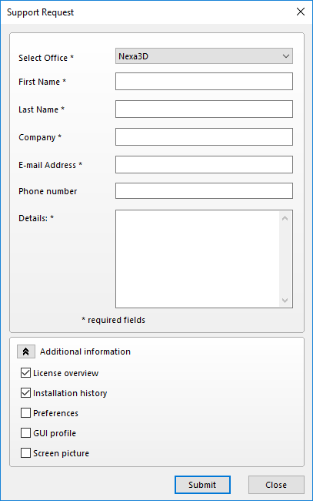MagicsPrint for Nexa3D allows you to send a support request by email to the customer support team of your Nexa3D. This can be done by filling out the request form and by selecting the type of additional information you want to add to the request.

To make sure that our customer support team has enough information regarding the problem, additional information can be included. You can select to add this information to your support request, which will give the customer support team more information about your MagicsPrint for Nexa3D configuration. By sharing this information it is more likely that your support case will be solved more swiftly.

# Additional Support

## Manual

You can access the manual for MagicsPrint for Nexa3D from within the software by going to Options&Help\Manual.

## Additional Contacts

For additional support, please contact your Nexa3D account representative.

You can contact Materialise directly by sending an email to [software.support@materialise.com](mailto:software.support@materialise.com) or call the support line at (734) 259-6445. Please include the software version of MagicsPrint for Nexa3D and your CCKey when sending in a support request.